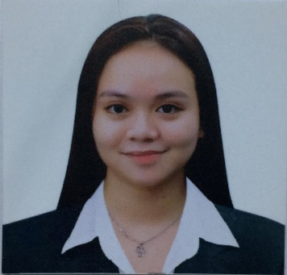**Nacion, Donna Mae C.**

26 I Bf Road Brgy. Holy Spirit, Quezon City

Email Address: donnanacion.13@gmail.com

Contact No.: 09812982081

_____________________________________________________________________________________

**OBJECTIVES:**

Looking forward for challenging career where I can be able to apply my qualification in order to pursue an opportunity to better serve and contribute to the company growth.

**PERSONAL INFORMATION:**

Age : 22 yrs. old

Date of Birth : September 13, 2000

Place of Birth : Las Piñas City

Civil Status : Single

Province : Ilocos Sur

Religion : Roman Catholic

Sex : Female

Father’s Name : Wilfredo Nacion

Mother’s Name : Digna Cabute

Height : 5’2

Weight : 53 klg.

**EDUCATIONAL BACKGROUND:**

*PRIMARY* DOÑA JUANA ELEMENTARY SCHOOL

Saint Catherine Corner Saint Peter, Quezon City

*S.Y. 2007-2008*

*SECONDARY* HOLY SPIRIT NATIONAL HIGH SCHOOL

Sto.Ireneo st, Doña Juana Ext. Brgy, Holy Spirit Q.C

*S.Y. 2016-2017*

*Senio High School Montessori Professional College of Asia*

*Luwell Bldg. Quirino Highway cor. Ascension Ave.  
 Lagro, Quezon City  
 S.Y. 2018-2019*

**WORKING EXPERIENCE:**

SALES LADY EXHIBIT

*Ever Gotesco Commonwealth*

KATIPID CONSUMER GOODS TRAIDING

*Sales Marketing Staff*

**CHARACTER REFERENCES**

Josie Villa

09616128396

TJ Olaguera

09636620183

*I hereby certify that the above data of information is true and correct to the best of my knowledge and belief.*

DONNA MAE C. NACION